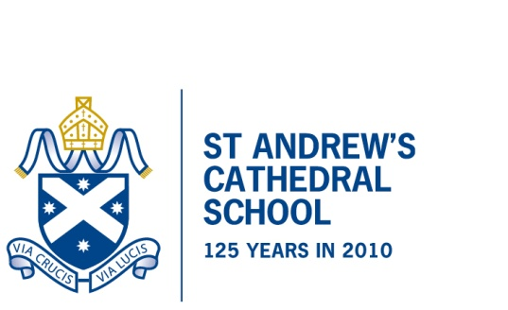
English Proficiency Requirements
- English as an Additional Language/Dialect (EAL/D) students
Any student who has studied in an English speaking institution for the last 5 years
or less and are from a non-English speaking background or speak a dialect other than Standard Australian English are considered English as an Additional Language/Dialect (EAL/D) student.

- Application for Years K-6.
EAL/D students entering our Junior School (Kindergarten to Year 6), will have their English Level judged at the enrolment interview. It is then the Head of Junior School’s decision whether to offer enrolment.

- Application for Years 7 to 11.
On enrolment application, EAL/D students should also provide a copy of results on a recent AEAS (Year 7 to 11), IDAT (Year 7to 11) or IELTS (Year 10 Semester 2 or Year 11) test (see note 5).
If the student has reached the required levels (see note 4) they will be invited to sit an English language proficiency test at St Andrew’s Cathedral School. If the school then considers their language proficiency to be adequate, they will be invited to start at the school.
If the student’s AEAS, IDAT IELTS or English language proficiency test results do not meet the school’s standard, they will be asked to attend an Intensive English College, or ELICOS (see note 6).
Then, once they receive results that indicate that they may have improved enough as indicated by a further AEAS, IDAT, IELTS and proven ELICOS results, they will be asked to sit the English language proficiency test again.

- The school’s English requirements.

Year | English Standard  AEAS | English Standard IDAT | English Standard IELTS
Years 7 and 8 | 61 | 60 | N/A
Year 9 to Year 10 Semester 1 | 71 | 70 | N/A
Year 10 Semester 2 to Year 11 | 81 | 80 | 6.5

- For more information see the following websites:
AEAS – aeas.com.au
IDAT – https://www.idat.org/handbook/210120_%20IDAT%20pamphlet%20ENG_digital.pdf
IELTS – ielts.org

- ELICOS Colleges.
For more information on our recommended ELICOS Colleges, please see:
https://www.sacs.nsw.edu.au/wp-content/uploads/2020/11/2020-ELICOS-Flyer-FA-DIGITAL.pdf

St Andrew’s Cathedral School, Sydney Square, Sydney NSW 2000
Telephone +61 2 9286 9500 Facsimile +61 2 9286 9550 www.sacs.nsw.edu.au ABN 34 429 367 893
CRICOS Registration: The Council of St Andrew's Cathedral School 02276M

